* **Things to carry :**
  + Aadhar card / Pan card / Driving licence
  + College ID
  + College Letter
  + Permission Letter from college *in case of change in team members*
  + Registration form Hard Copy
  + Travel Allowance Form : **I don’t know what it is**
  + Travel Bills : *One hardcopy per team member* ***Needs to be attached with Travel Allowance Form***
  + Team Tshirt : Team name , logo, college name , SIH logo [Right Side Chest Section]
  + Standees : Team name , Team , college name , min 6x2 ft

* **Standee :**

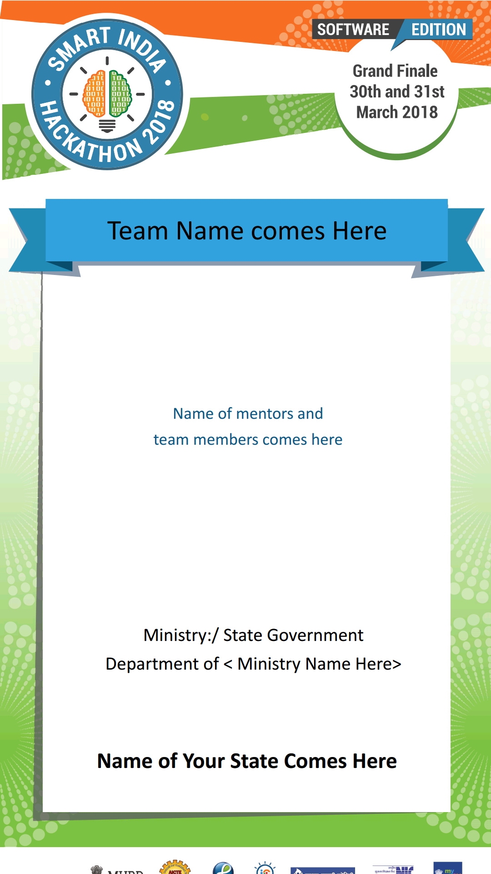

**Banner :**

